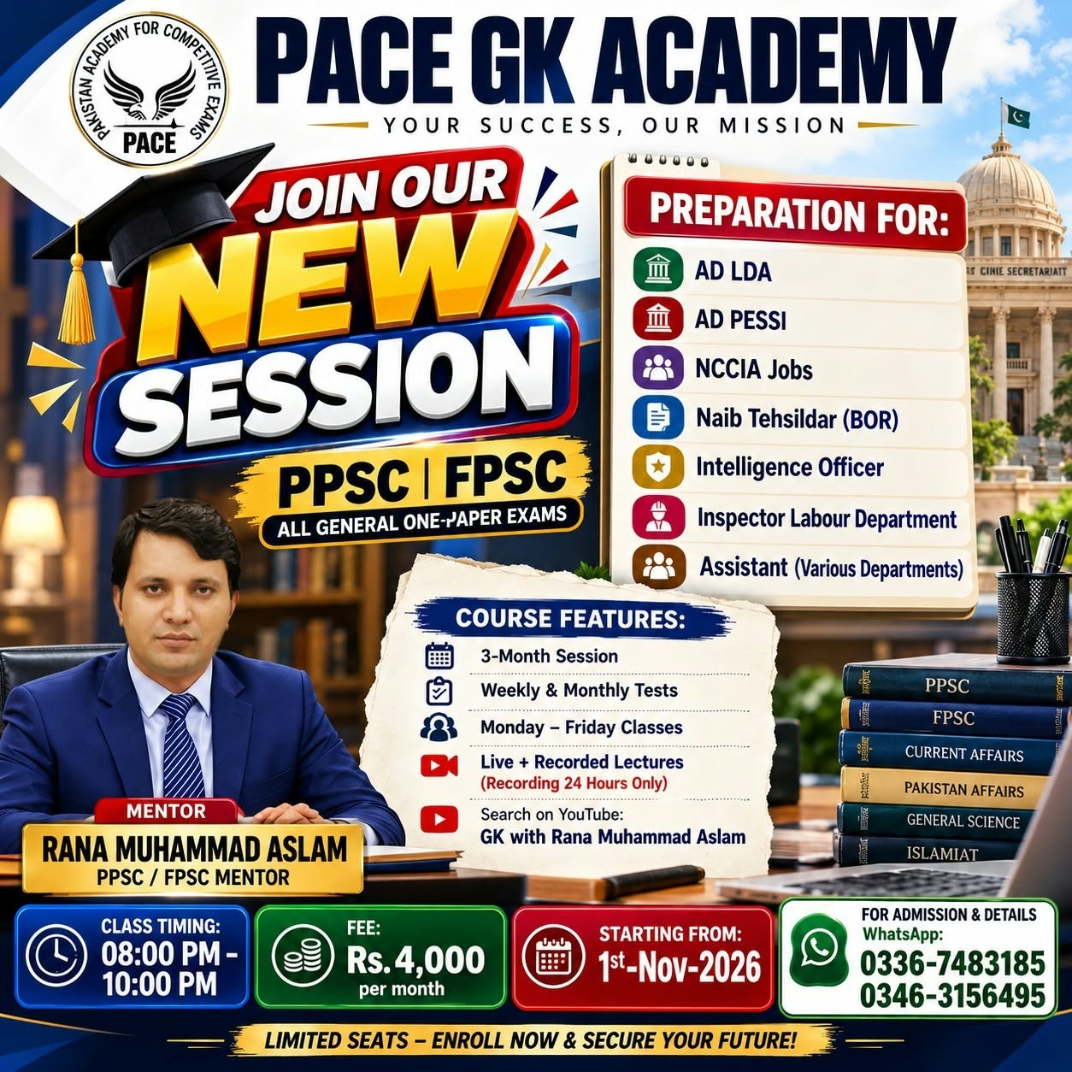

PACE GK ACADEMY – NEW SESSION ANNOUNCEMENT 2026

JOIN OUR NEW SESSION FOR PPSC | FPSC & ALL GENERAL ONE-PAPER EXAMS

Are you preparing for government jobs? Start your preparation with expert guidance and a well-organized study plan at PACE GK ACADEMY (Multan)

📚 PREPARATION FOR:
✅ AD LDA
✅ AD PESSI
✅ NCCIA Jobs
✅ Naib Tehsildar (BOR)
✅ Intelligence Officer
✅ Inspector Labour Department
✅ Assistant (Various Departments)
✅ Other General One-Paper Exams

🌟 COURSE FEATURES:
📌 3-Month Session
📌 Weekly & Monthly Tests
📌 Monday to Friday Classes
📌 Live + Recorded Lectures
📌 Recordings Available for 24 Hours Only
📌 Search on YouTube: GK with Rana Muhammad Aslam

👨‍🏫 MENTOR: Rana Muhammad Aslam
PPSC / FPSC Mentor

🕗 CLASS TIMING: 08:00 PM – 10:00 PM
💰 MONTHLY FEE: Rs. 4,000/-
📅 STARTING DATE: 1st November 2026

📲 FOR ADMISSION & DETAILS, CONTACT US ON WHATSAPP:

📞 0336-7483185
📞 0346-3156495

🔥 LIMITED SEATS – ENROLL NOW & SECURE YOUR FUTURE!

🎯 Take the next step toward your dream government job with PACE GK ACADEMY.

Share this post with your friends who are preparing for PPSC, FPSC and other government job exams.



PACE PPSC PAST PAPERS TEST SERIES 2026

Pakistan Academy for Competitive Exams (PACE)

Mentor: Rana M. Aslam
PPSC/FPSC Mentor

PREPARATION FOR THE FOLLOWING JOBS:
✅ NCCIA Jobs
✅ Intelligence Officer
✅ Naib Tehsildar (BOR)
✅ Junior Clerk
✅ Assistant (Various Departments)
✅ AD PESSI
✅ Tehsil Sports Officer(GK)

WHAT WILL YOU GET ?
🔹 All Past Papers from 2021 to 2026
🔹 Discussion Class After Each Paper
🔹 Error-Free Past Papers
🔹 Solved Math Portion Videos
🔹 Total Tests: 22

TEST SERIES FEE: Rs. 1,000/-
SESSION DURATION: 2 Months
STARTING DATE: 20 October 2026

REGISTRATION VIA WHATSAPP:
📞 0300-1757495
📞 0345-0668111

Prepare with Confidence. Practice with PACE. Move Towards Success!

Join PACE and make your preparation more effective for upcoming competitive examinations.

Limited Time to Prepare — Register Now!

